Title: The Winter's Tale
Year: 2019
Company: Goodman Theatre

May 4 – Jun 9, 2019 in Goodman's Albert Theatre
2 hours and 15 minutes with one intermission

“No modern American director is better at making a play’s iconic moments pop with fresh irreverence” (Chicago Tribune)
A jealous king accuses his wife of infidelity, setting off a calamitous series of events. But what begins as tragedy evolves, unexpectedly, into a fantastical journey—from wrath to redemption to reconciliation. Following his celebrated productions of King Lear and Measure for Measure, Robert Falls reimagines one of Shakespeare’s most wildly theatrical tales.
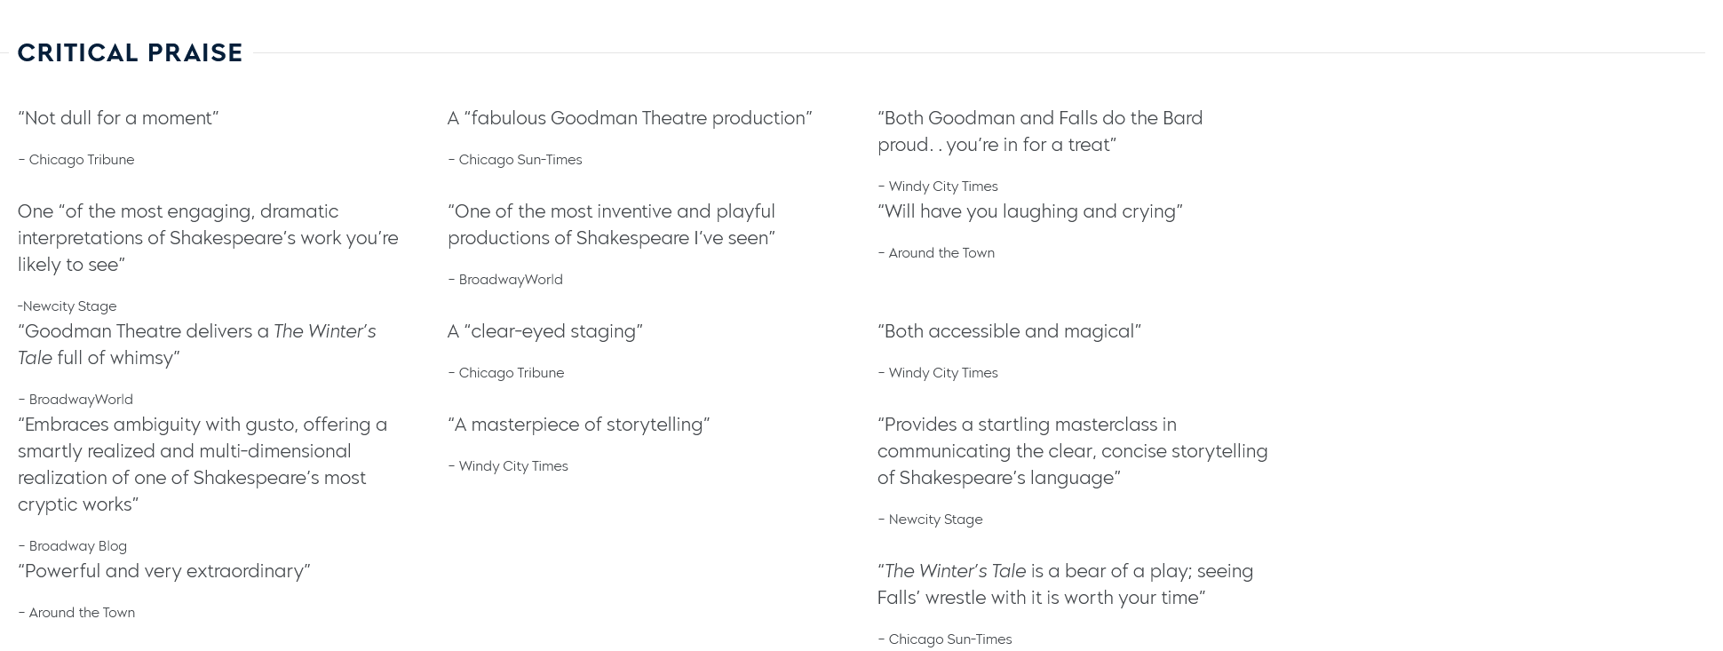

https://www.newcitystage.com/2019/05/14/a-tale-of-two-tales-a-review-of-the-winters-tale-at-goodman-theatre/

https://stageandcinema.com/2019/05/14/winters-tale-goodman/

https://aroundthetownchicago.com/theatre-reviews/the-winters-tale/

https://www.picturethispost.com/goodman-theatre-presents-the-winters-tale-review/

https://www.broadwayworld.com/chicago/article/BWW-Review-THE-WINTERS-TALE-at-Goodman-Theatre-20190514

https://chicago.suntimes.com/2019/5/14/18626969/winter-s-tale-as-confounding-as-ever-in-fabulous-goodman-theatre-production

https://splashmags.com/2019/05/a-winters-tale-at-the-goodman-theatre-review-an-obscure-delight/

